AI ASSISTED CODING
LAB-14.1

NAME:: RAJESH
BATCH :: 44
ROLL NO:: 2303A52459
TASK-1 : Portfolio Website Design
PROMPT :
Generate a simple and responsive personal portfolio website using HTML,
CSS, and JavaScript. The website should include three sections: About Me, Projects, and Contact. Use a clean layout with basic styling and a navigation bar at the top. Implement smooth scrolling when navigation links are clicked. The design should be user-friendly and suitable for a student portfolio.
CODE :
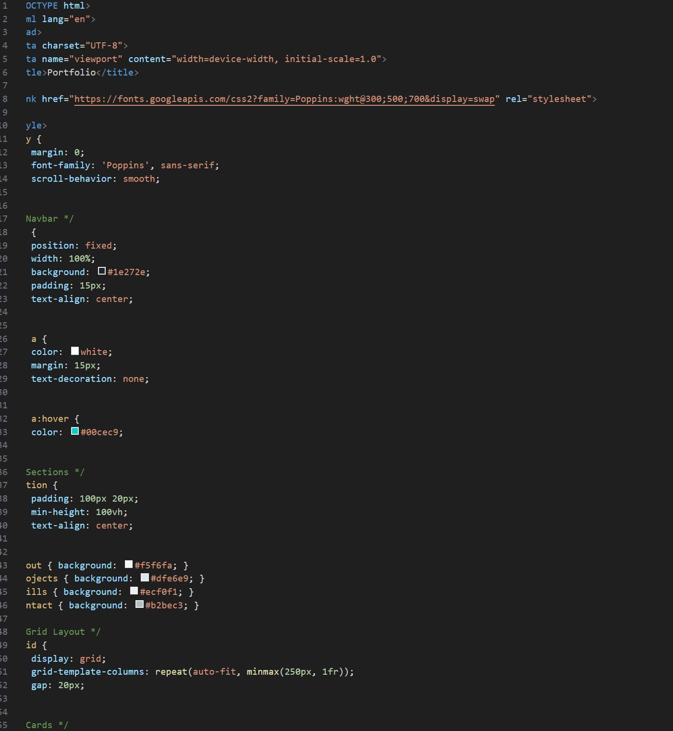

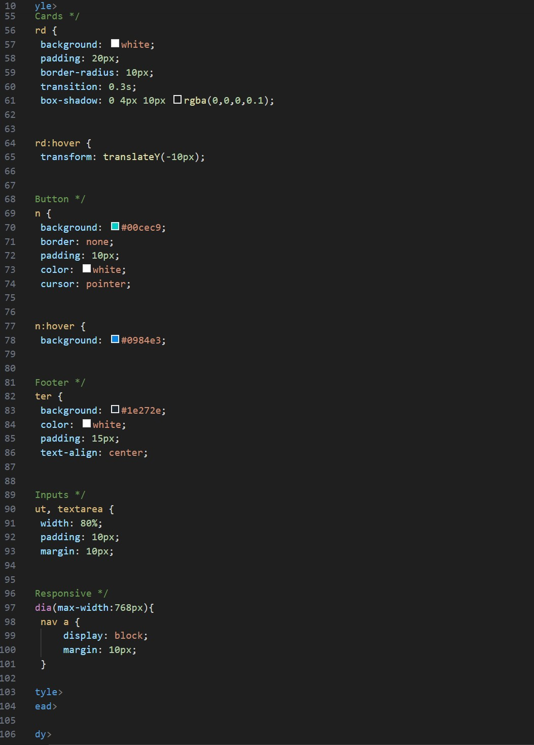

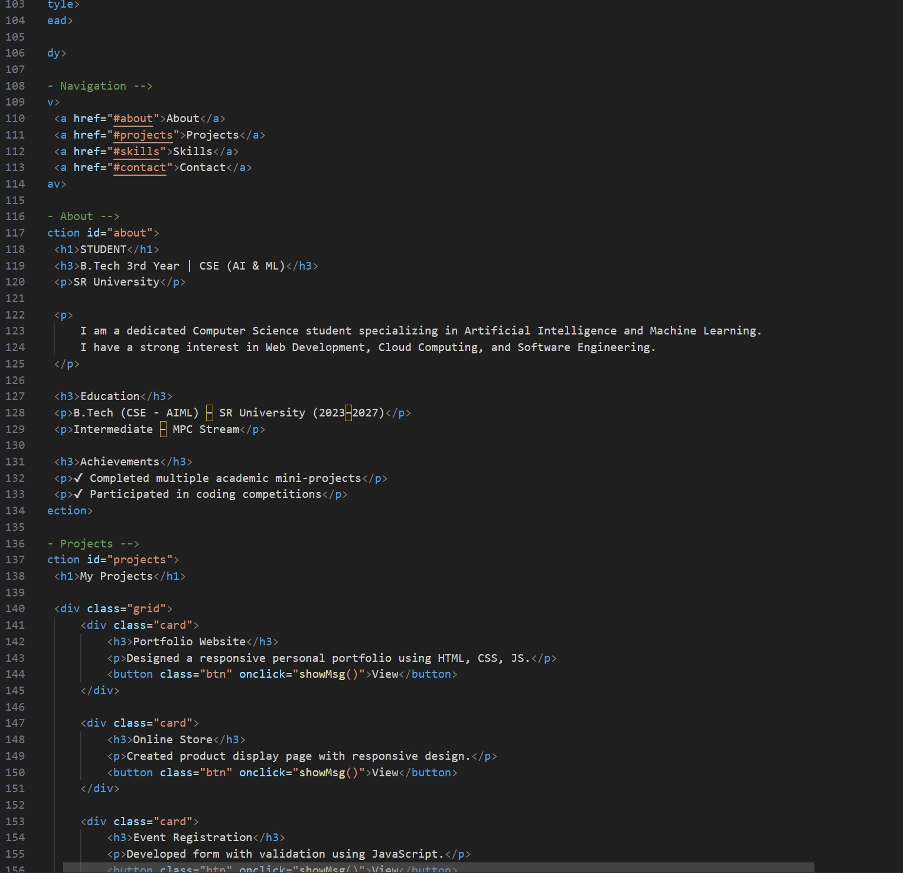

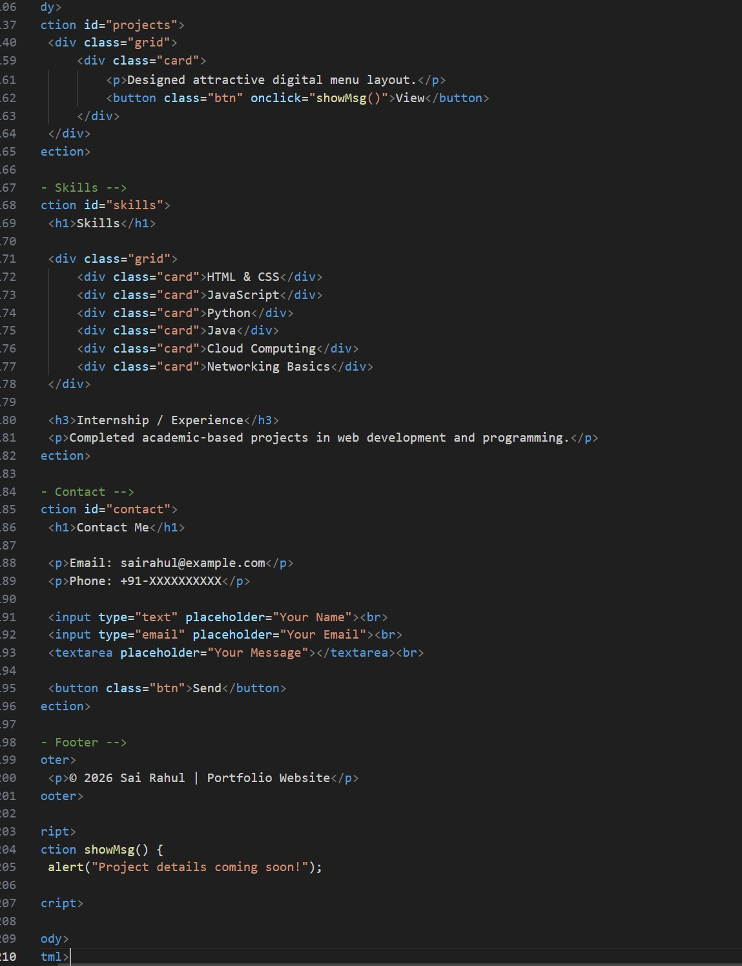

OUTPUT :
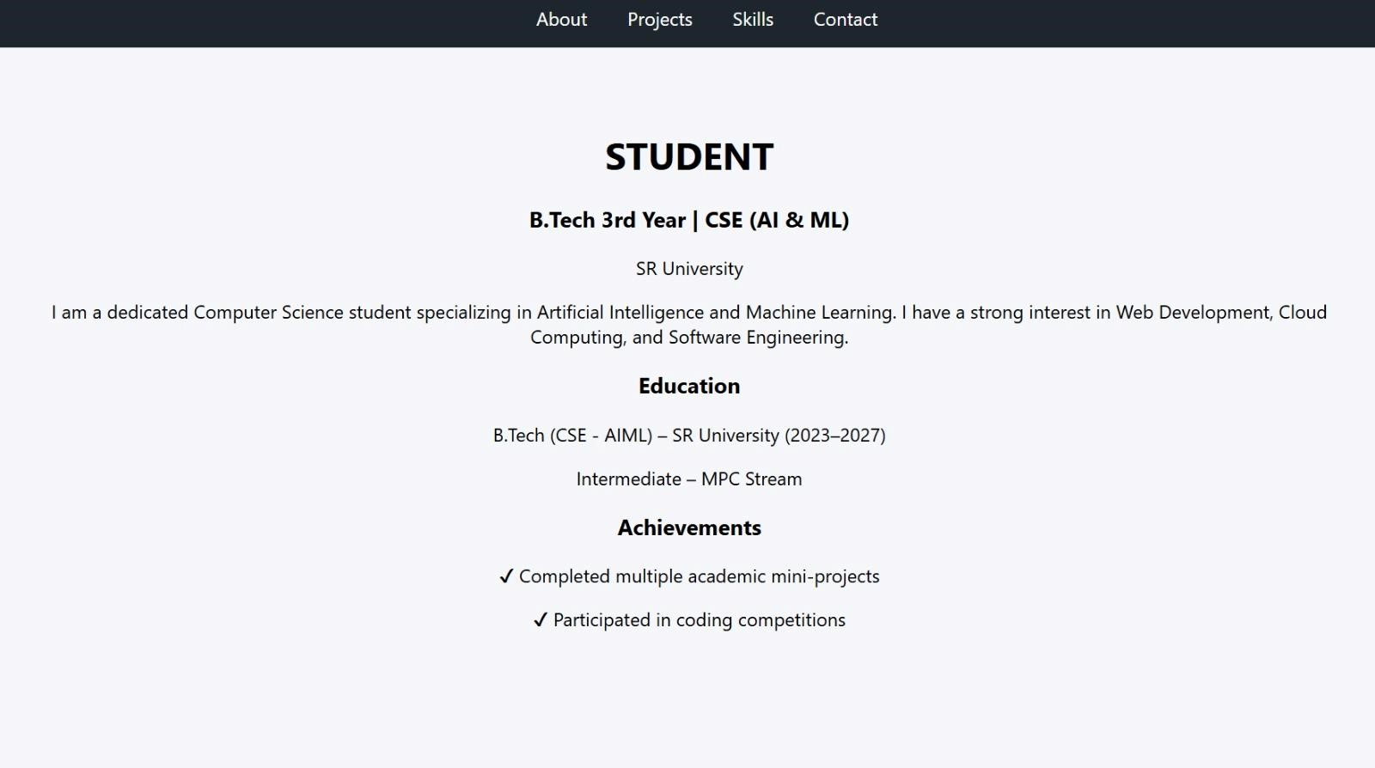
OBSERVATION :
The portfolio website was developed using HTML, CSS, and JavaScript with sections for About, Projects, and Contact. Smooth scrolling navigation was implemented to enhance user experience and provide easy access between different sections. TASK-2 : Online Store Product Page PROMPT :
Create a responsive product display page for an online store using HTML,
CSS, and JavaScript. Display multiple products with image, title, price in Indian Rupees, and an Add to Cart button. Use BEM methodology for class naming, add hover effects, and show an alert message when a product is added to the cart.

CODE :
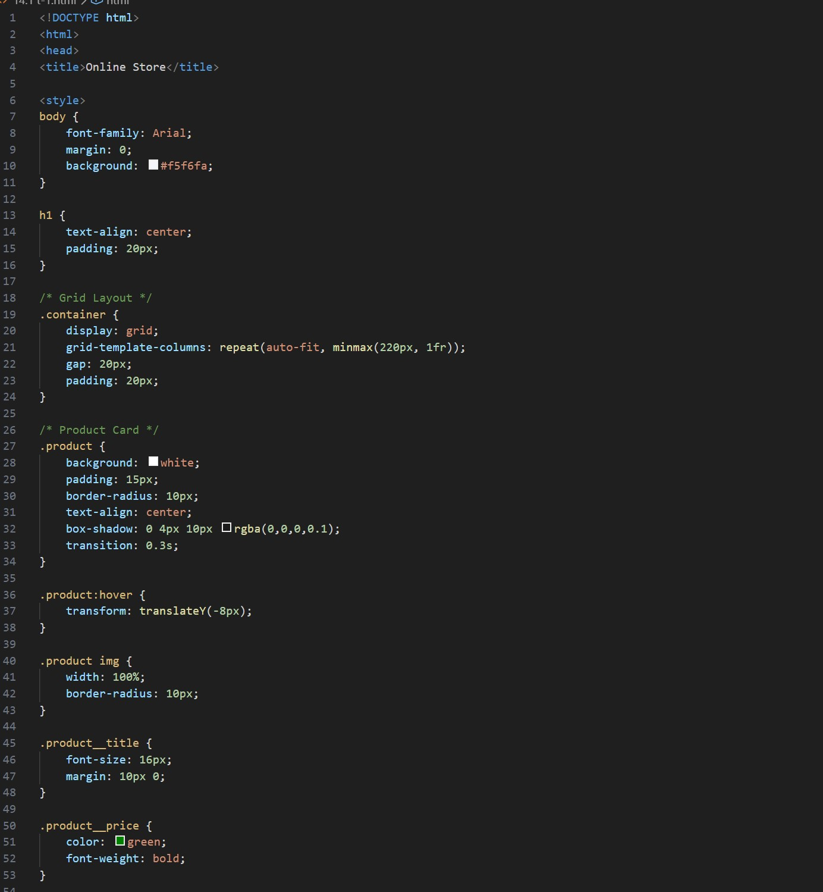

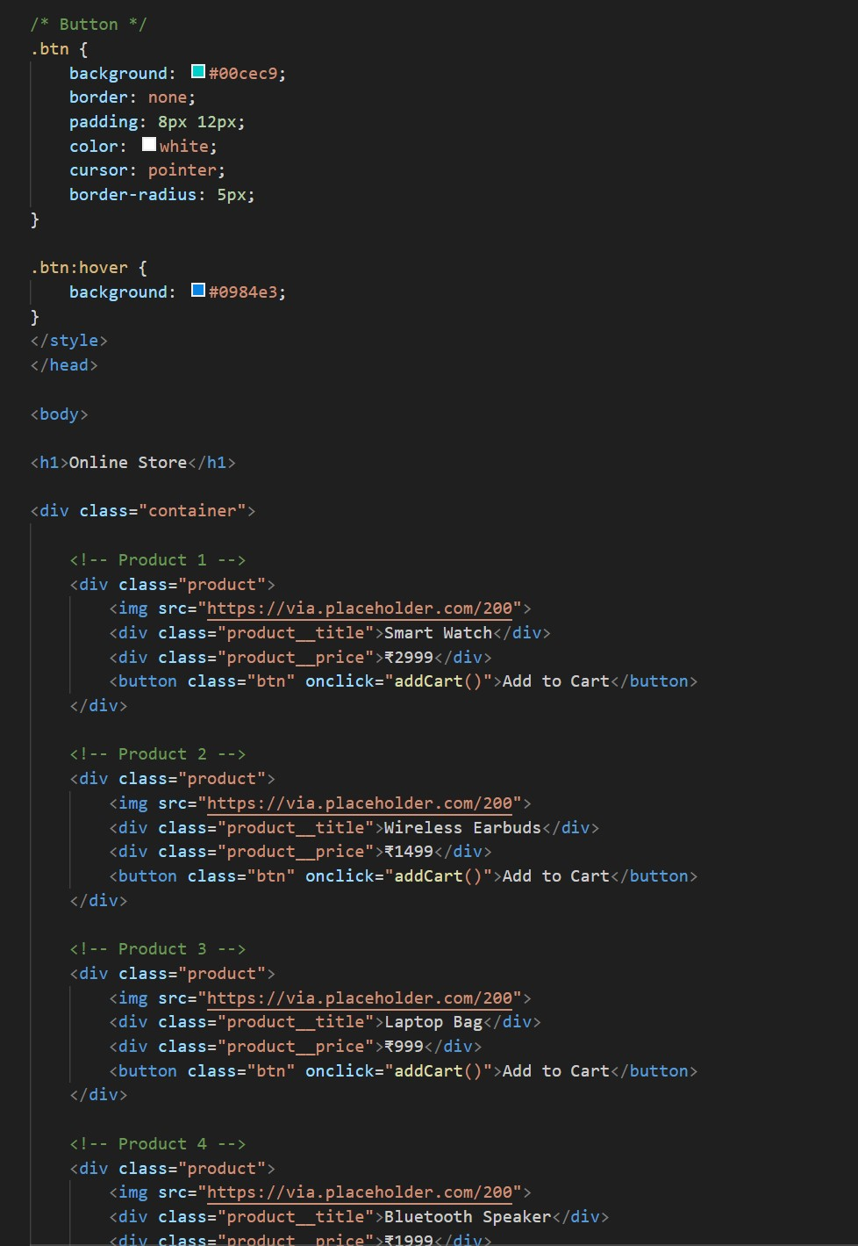

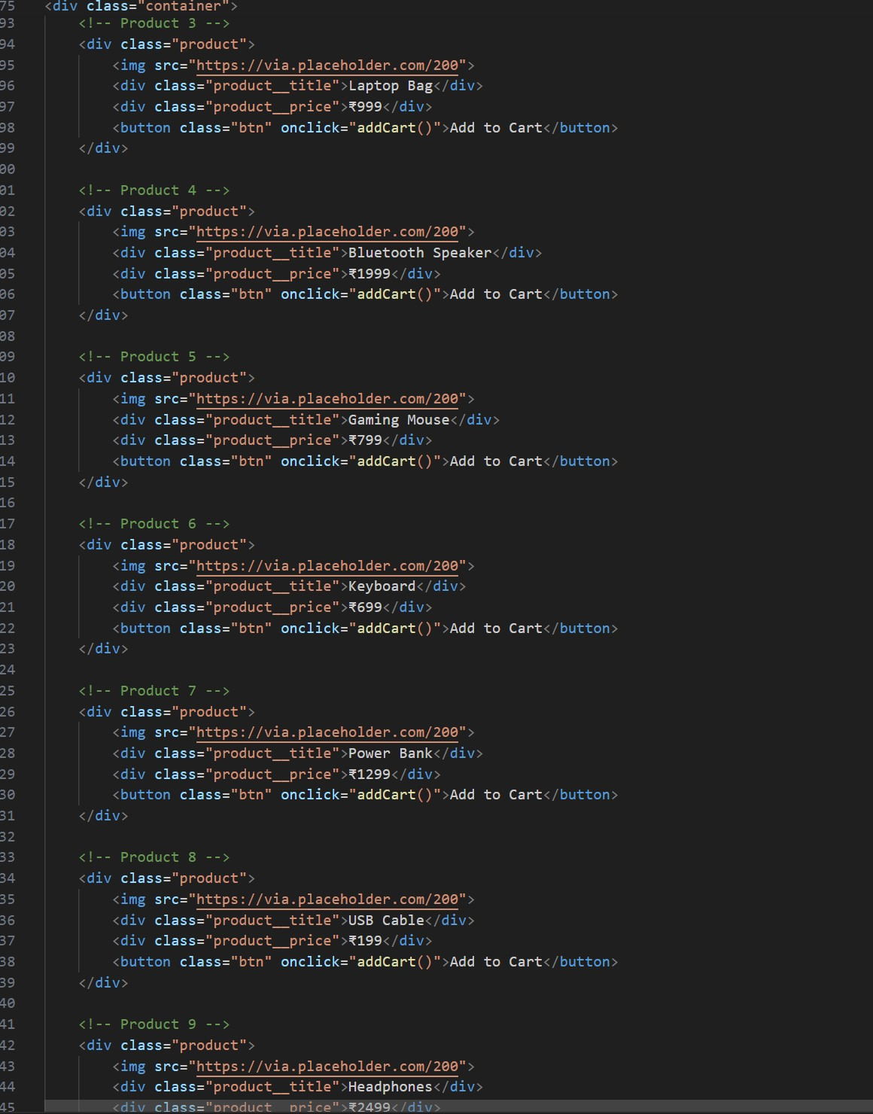

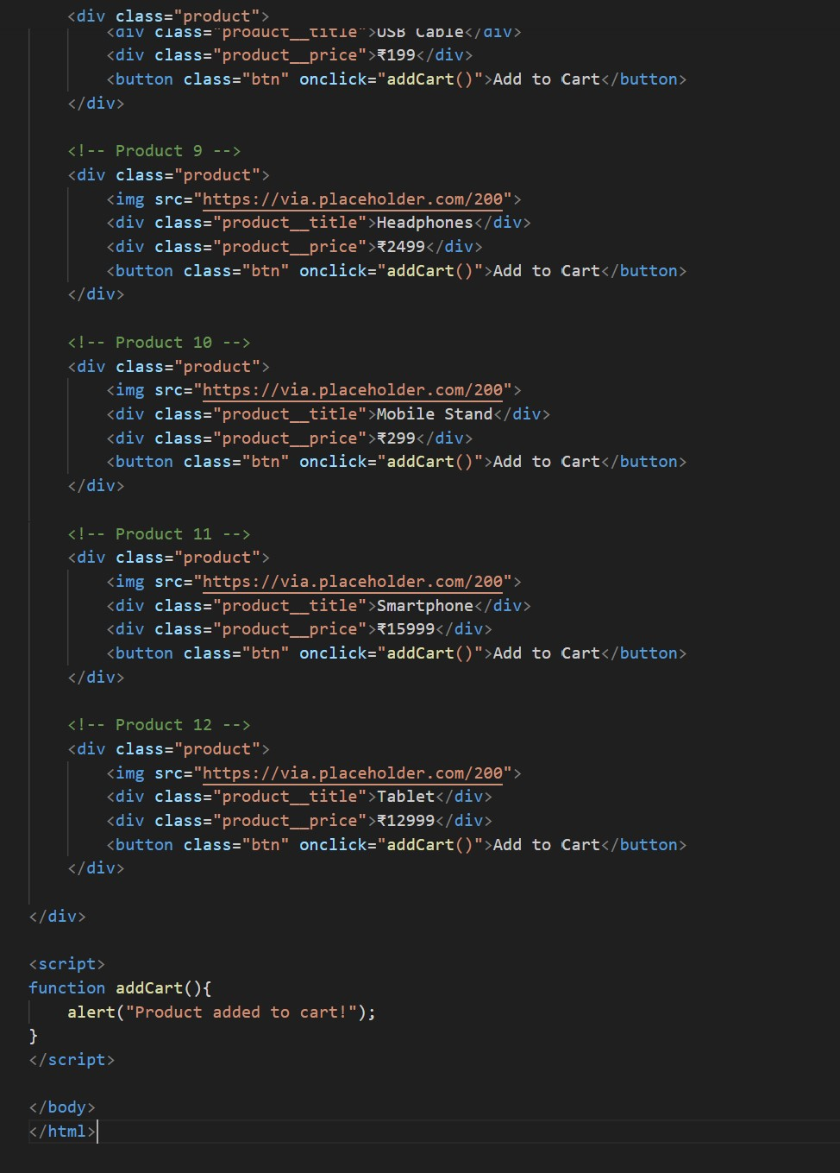

OUTPUT :
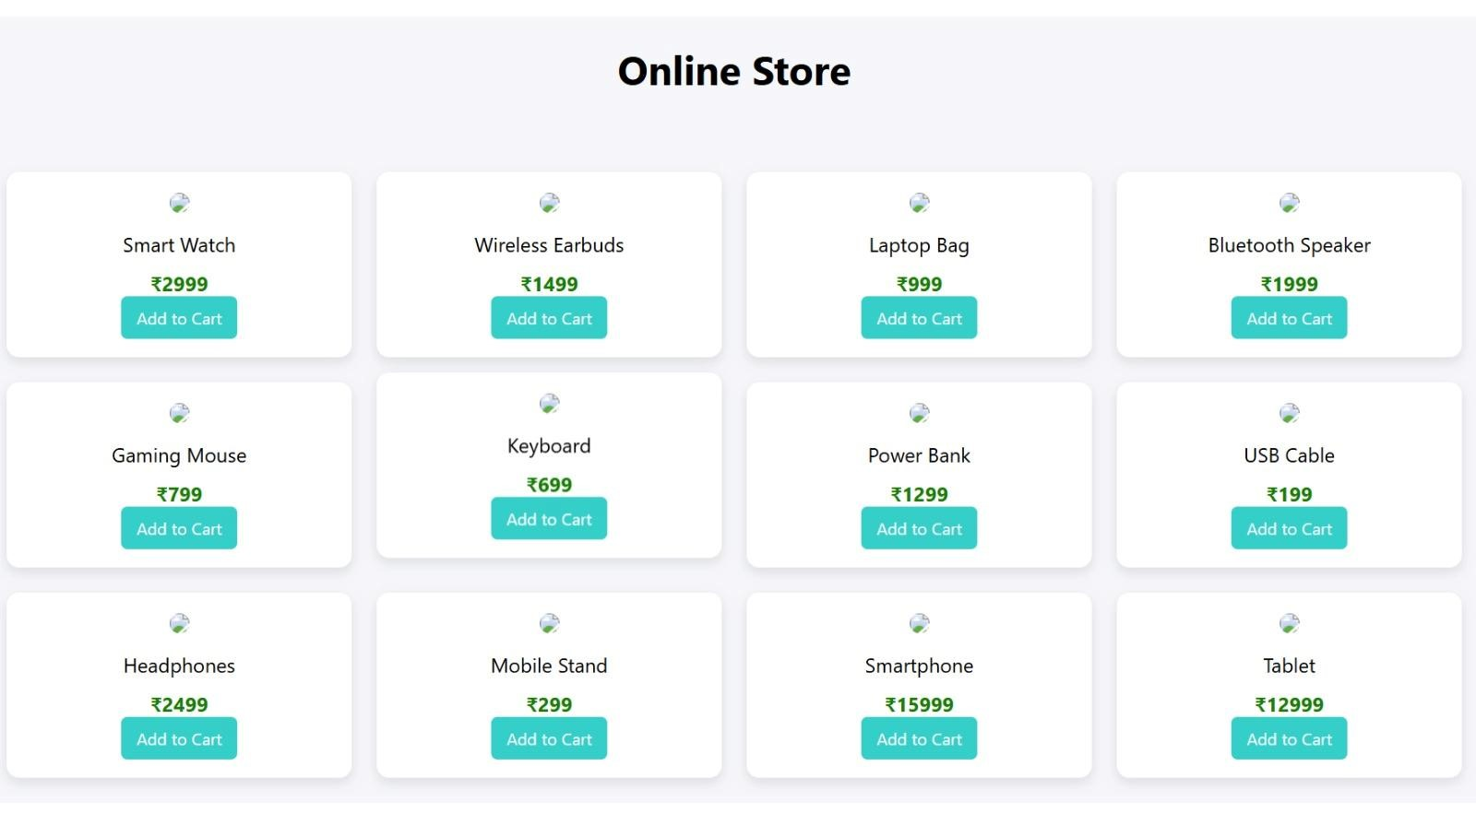
OBSERVATION :
A responsive product page was designed to display multiple products with images, prices in Indian Rupees, and an Add to Cart feature. BEM methodology was used for structured class naming, and hover effects were added to improve visual interaction. TASK-3 : Event Registration Form Prompt PROMPT :
Design an event registration form using HTML, CSS, and JavaScript. The form should collect name, email, phone number, and session selection. Add input validation using JavaScript, ensure proper labels for accessibility, and style the form with a clean and professional layout.

CODE :
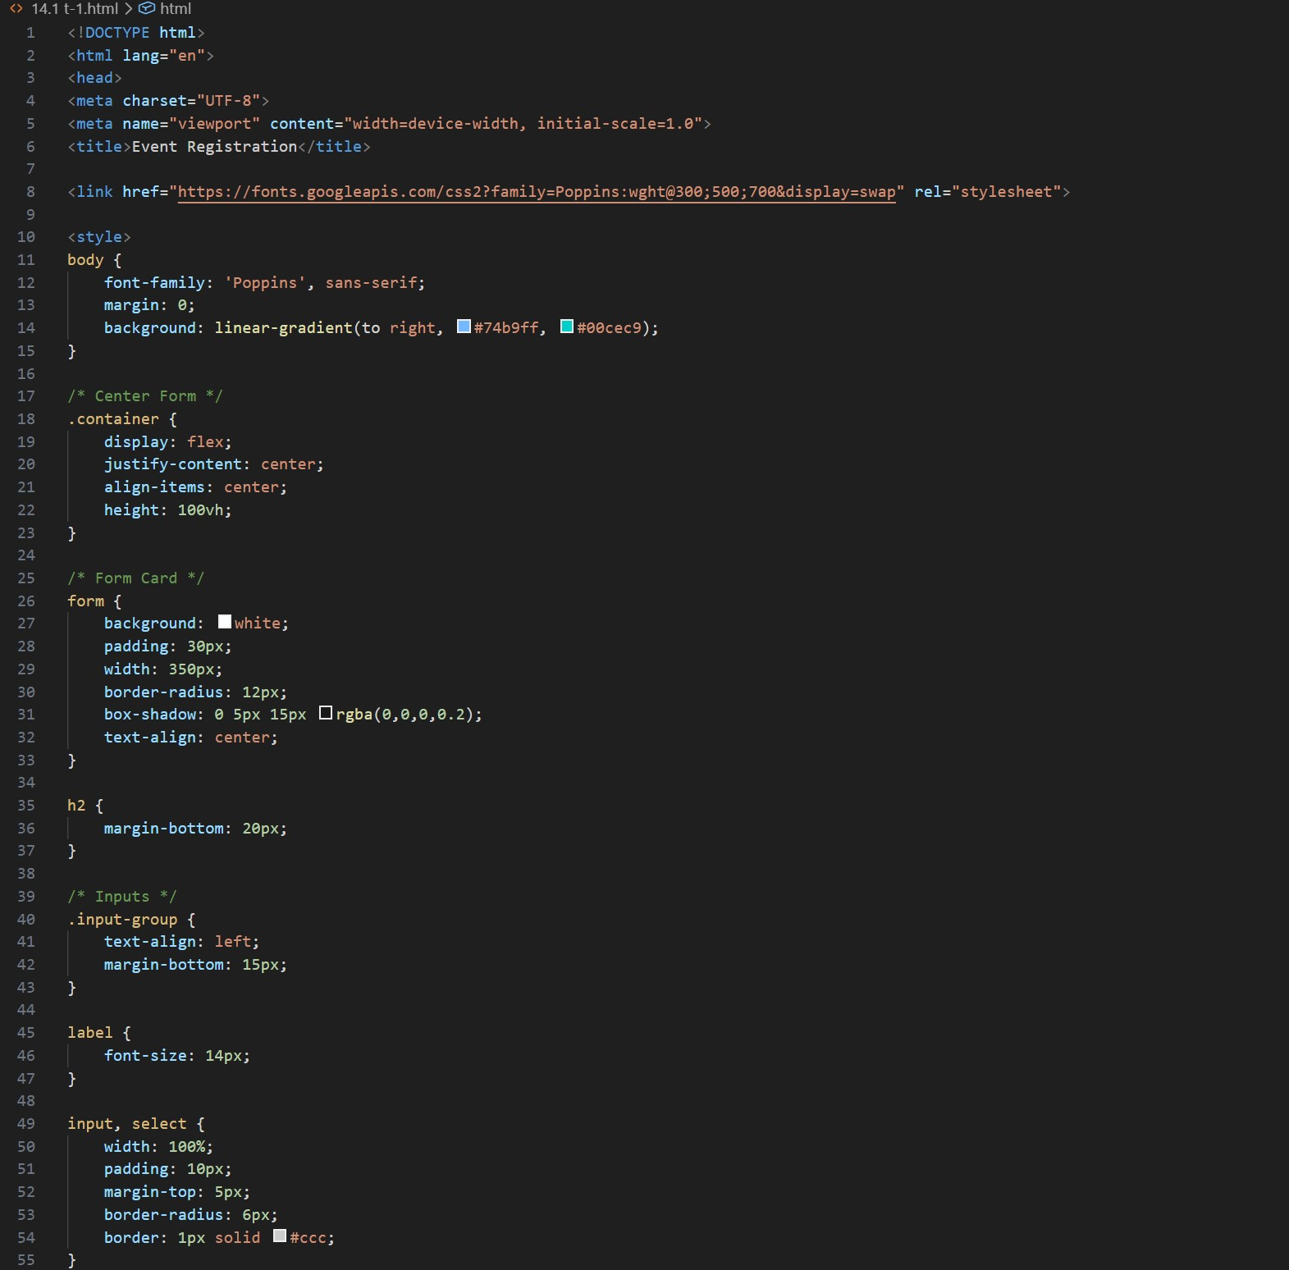

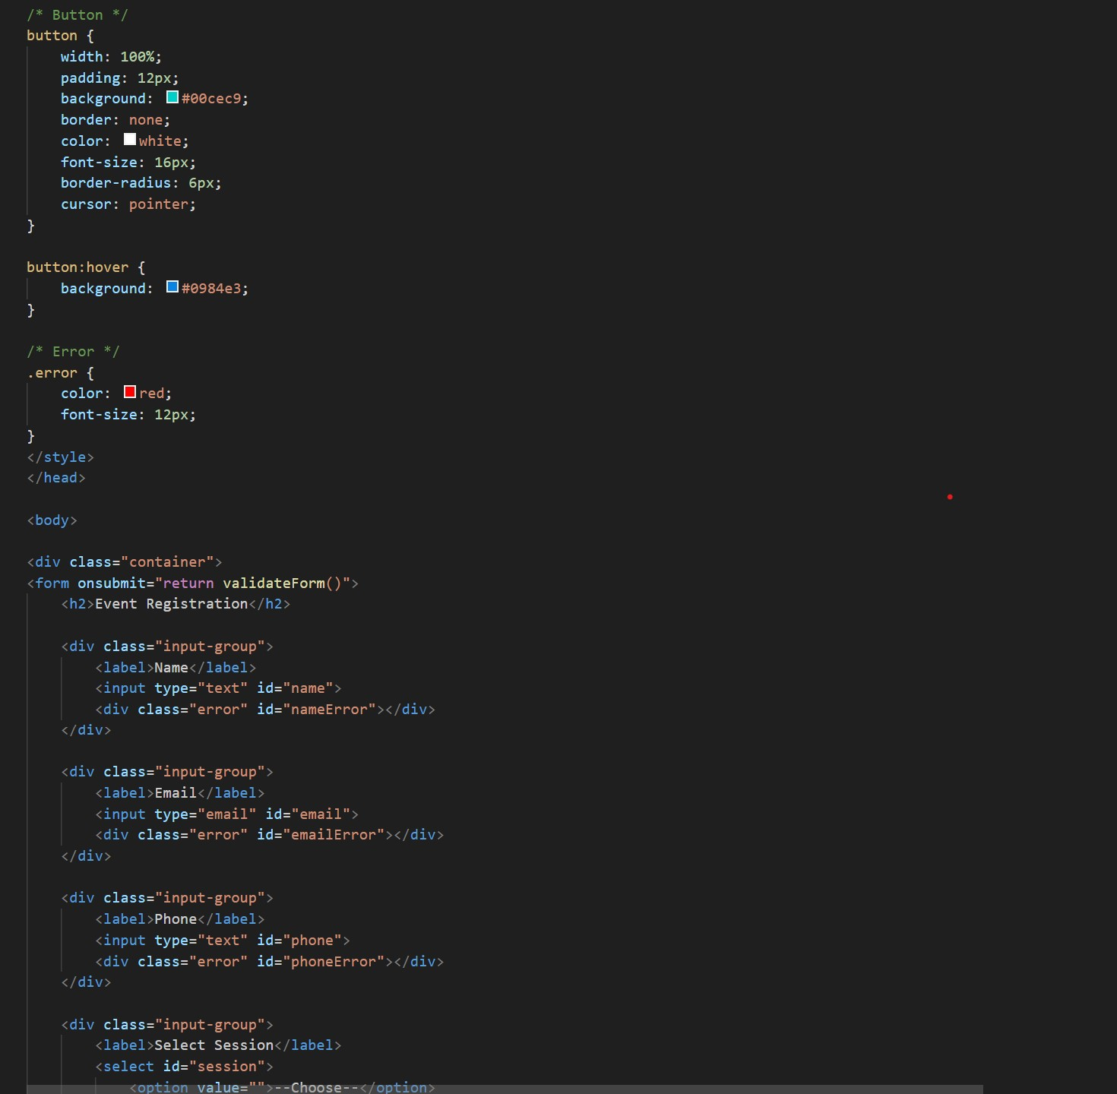

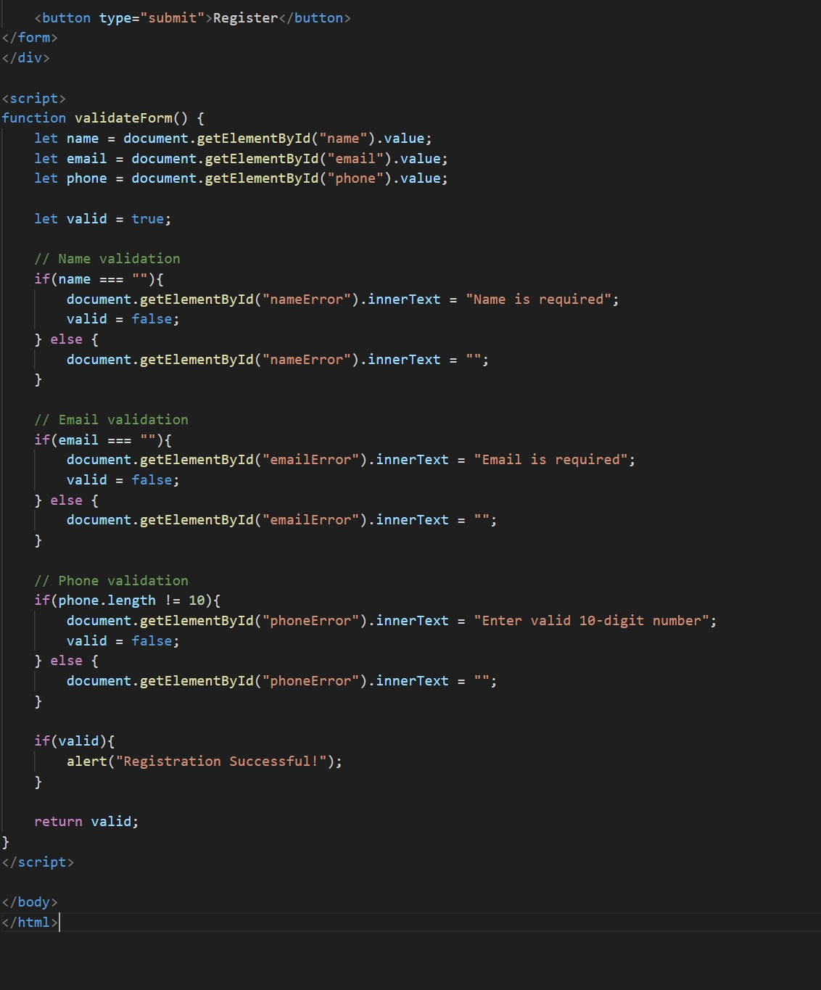

OUTPUT :
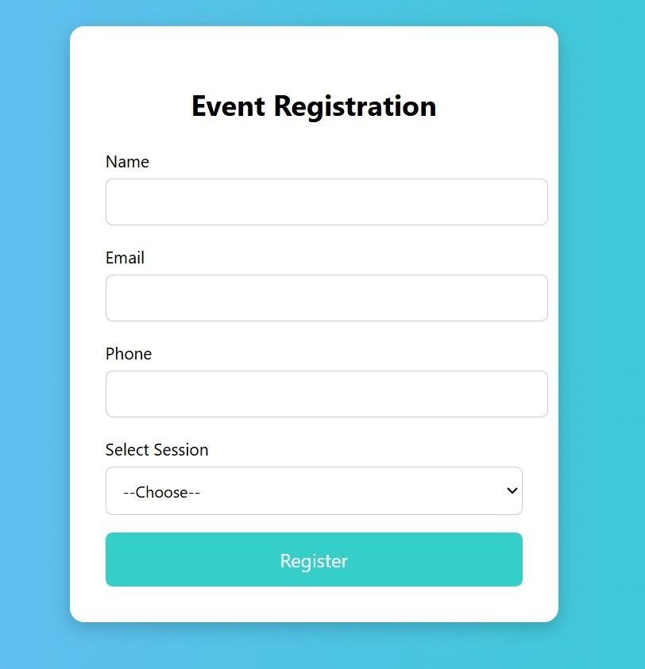
OBSERVATION :
An event registration form was created to collect user details such as name, email, phone number, and session selection. JavaScript validation was implemented to ensure correct input, particularly for validating the phone number format.

TASK-4 : Resume Website Prompt PROMPT :
Build a one-page resume website using HTML and CSS. Include sections for Profile Summary, Skills, Education, and Experience. Use CSS Grid for layout alignment and apply simple, professional typography. Add smooth navigation between sections.

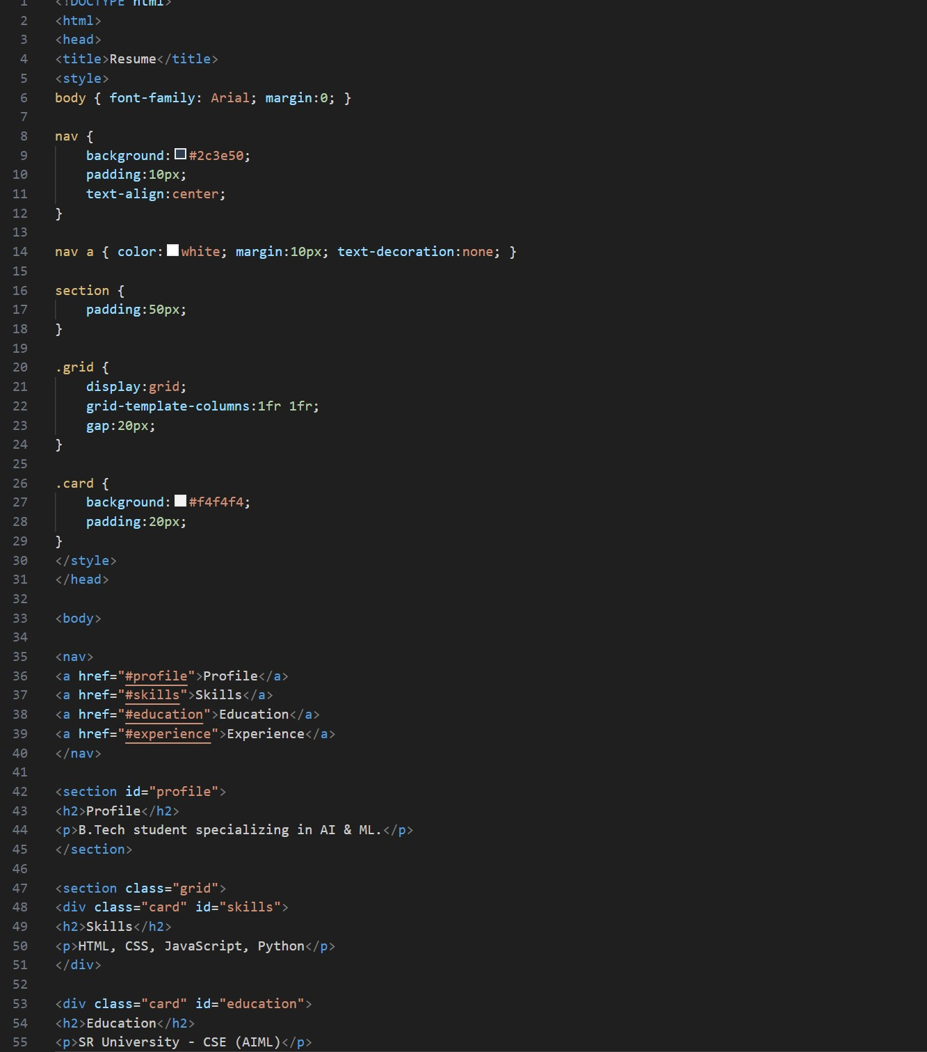
CODE :

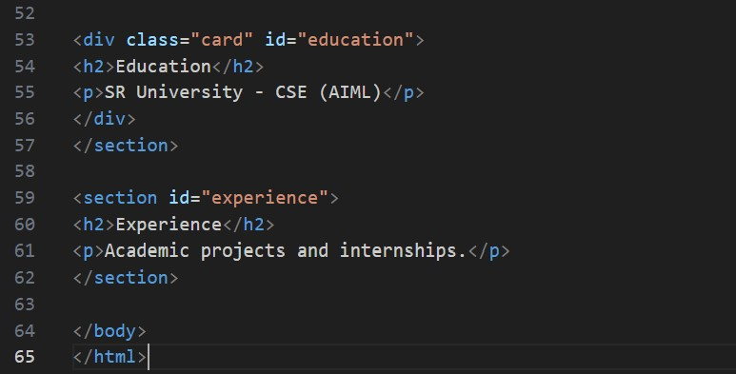

OUTPUT :

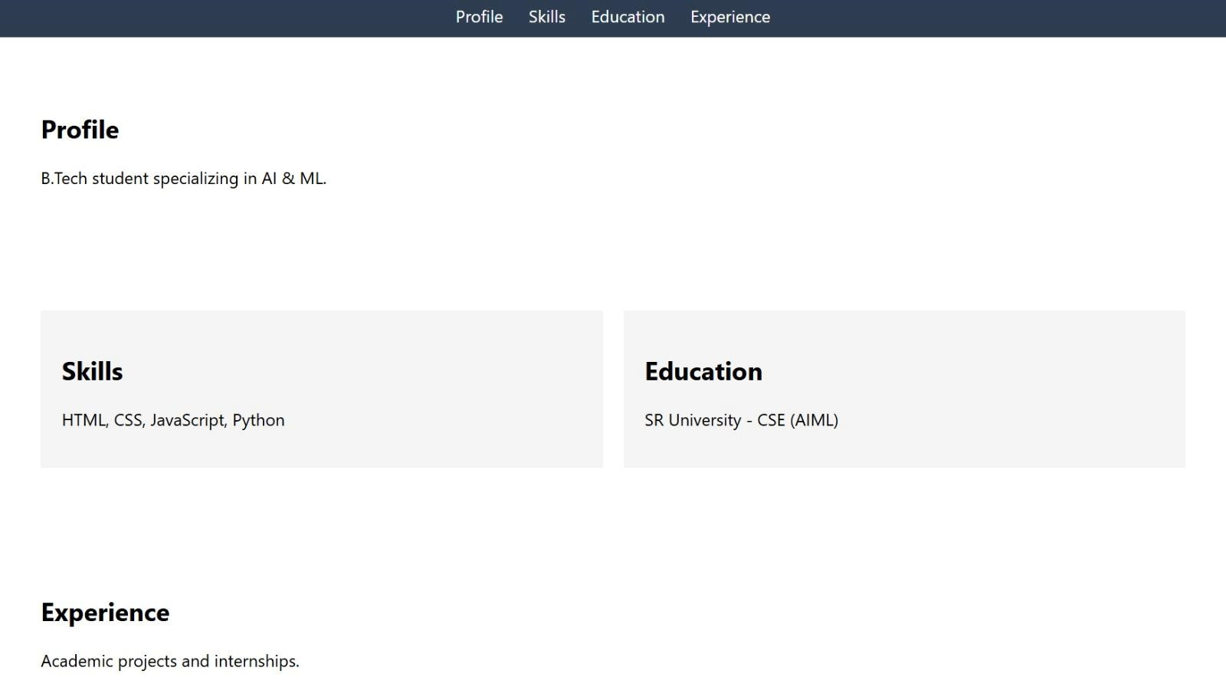
OBSERVATION :
A one-page resume website was developed with sections including profile summary, skills, education, and experience. CSS Grid was used to align the content effectively, resulting in a clean and professional layout.

TASK-5 : Restaurant Menu Page Prompt PROMPT :
Create a digital restaurant menu page using HTML and CSS. Display menu items with name, description, and price. Use a responsive card-based layout, apply a food-friendly color palette, and add hover effects to enhance user interaction.

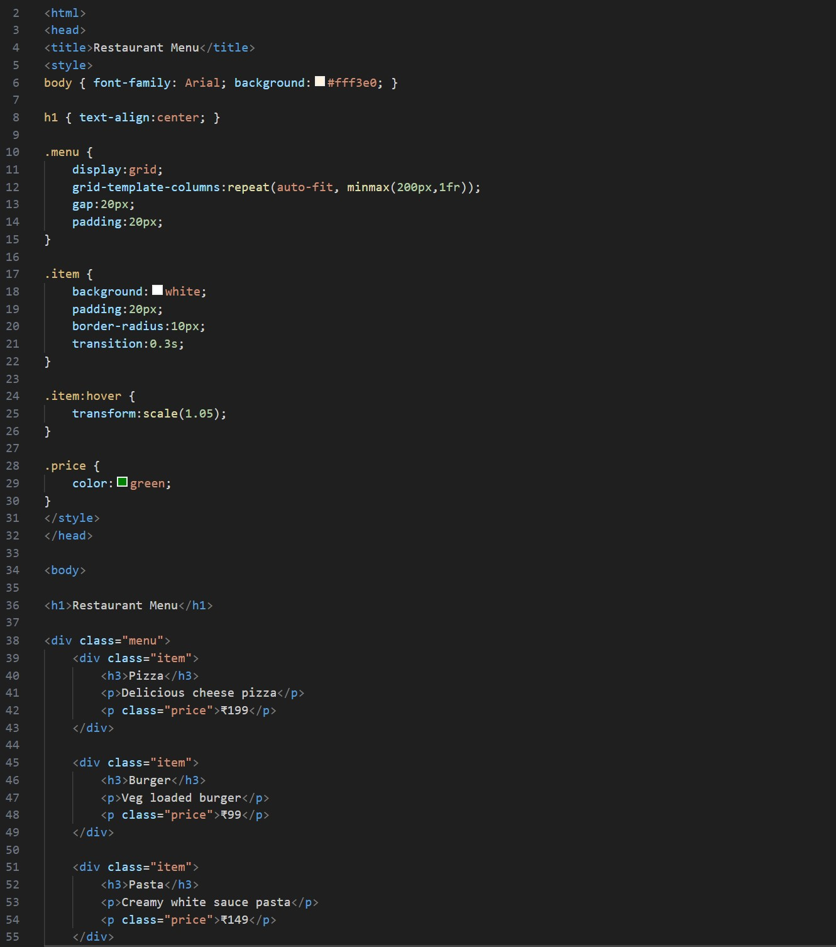
CODE :

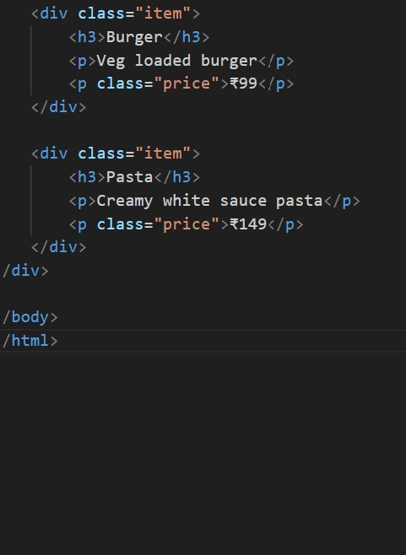

OUTPUT :

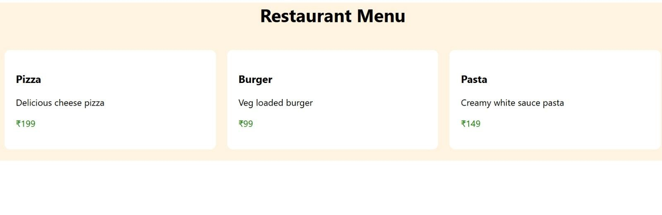
OBSERVATION :
A digital restaurant menu page was designed to display food items with their names, descriptions, and prices. A card-based layout with hover effects was implemented to enhance visual appeal and ensure responsiveness.

